**Chapter 3**

**Specific Factors Model**

*Who gains? Who loses? Under what circumstances?*

* **Ricardian Model Vs SFM:**

Crucial assumption of the Ricardian Model: Labor is the only factor of production.

Result obtained: trade generates gains for **all** workers!

What if we have two factors of production in the model ?

Then, trade will generate gains for some factors and losses for others.

However, the overall gains from those who benefit from trade generally exceed the losses of those who are harmed.

* **Specific Factors Model:**

**2 x 2 x 3**

3 Factors: Land (Z), Labor (L), Capital (K)

2 Industries/Sectors: Agriculture (A), Manufacturing (M)

2 Countries: Home (H), Foreign (F)

Sector A uses L and Z

Sector M uses L and K

Z is specific to sector A

K is specific to sector M

L is not specific to A or M sectors

In each sector, L is subject to diminishing returns

* MPL ↓ as amount of L used ↑
* As more L is used, the output goes up, but it does so at a diminishing rate.

(Recall: MPL or Marginal Productivity of Labor is the change in output associated with a change in amount of labor used, holding other inputs into production constant)

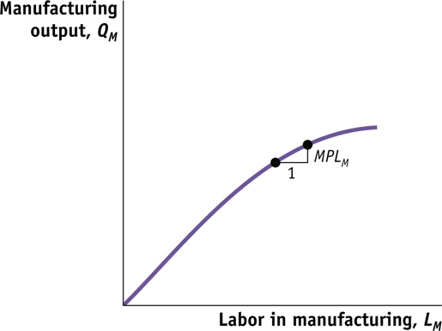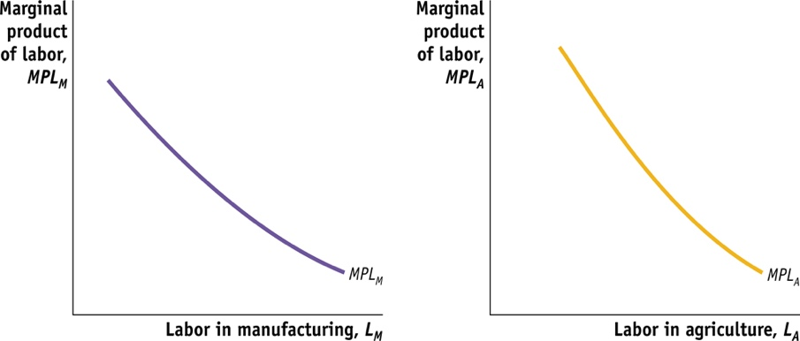

**Short run model**

* Since Z and K cannot be shifted from use in one sector to use in another.

Question: How trade affects earnings of specific or fixed factors and of mobile factors?

* How changes in relative prices affect the earnings of L, K and Z?

**PPF or Production Possibilities Frontier**

* Obtained by combining the output for the two sectors
* PPF is concave or bowed out due to diminishing returns in L
* Slope of PPF = - MPLA /MPLM = opportunity cost of producing 1 unit of output in sector M

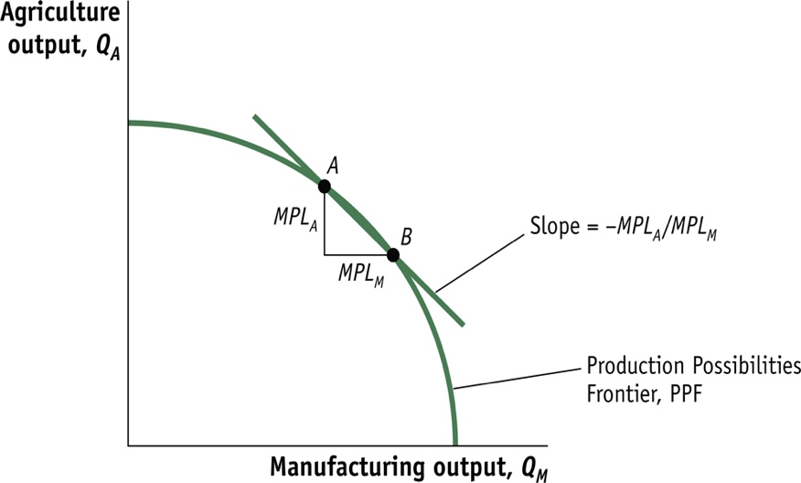

In competitive markets,

Wage = Value of MPL

In sector A, WA = PA∙ MPLA

In sector M, WM = PM∙ MPLM

Since labor is free to move between sectors, WA = WM

* PA∙ MPLA = PM∙ MPLM
* PM /PA  = MPLA /MPLM
* Relative price of manufacturing = opportunity cost of manufacturing

(Note: If WA is not equal to WM, L from low wage sector will move to high wage sector until ↑ of L in high wage sector ↓ wage, and ↓ of L in low wage sector ↑ wage, and wages are equalized across sectors.)

**No trade equilibrium in Home:**

In **autarky** (in the absence of international trade), the equilibrium for H is obtained at point where relative price of manufacturing = slope of PPF = slope of IC

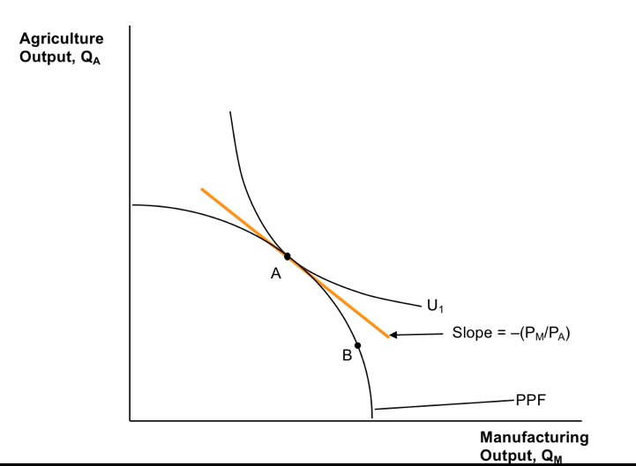

**Assumption:**

The no trade relative price of manufacturing at H < relative price of manufacturing at H

* PM /PA  < P*M /P*A
* H can produce manufacturing goods relatively cheaper than F
* H has comparative advantage in manufacturing

**Gains from Trade:**

H exports M and imports A, and consumes at a higher IC

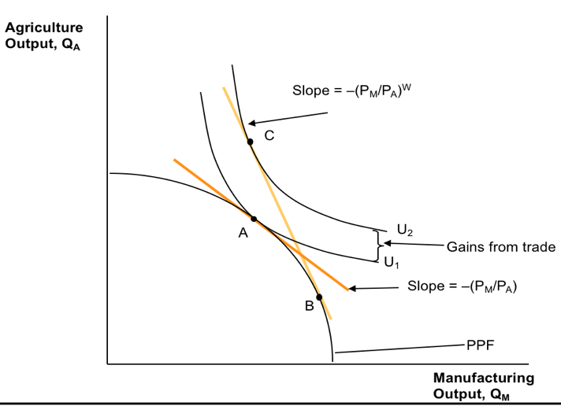

**How large are gains from trade?**

* Japan experienced gains from trade when it engaged in international trade in 1859 after 200 years of self-imposed autarky. Japan’s gains from trade are estimated to be about 4% to 5% of GDP.
* The United States experienced the reversal of gains from trade when the U.S. Congress imposed an **embargo** (a complete stop to all trade) on trade with Britain between December, 1807, and March, 1809. The gains from trade for the United States would have been at least 5% of GDP without the embargo.

**Earnings of Labor**

To determine the impact of international trade on wages in the two sectors, first put the marginal product of labor for agriculture and manufacturing on the same graph.

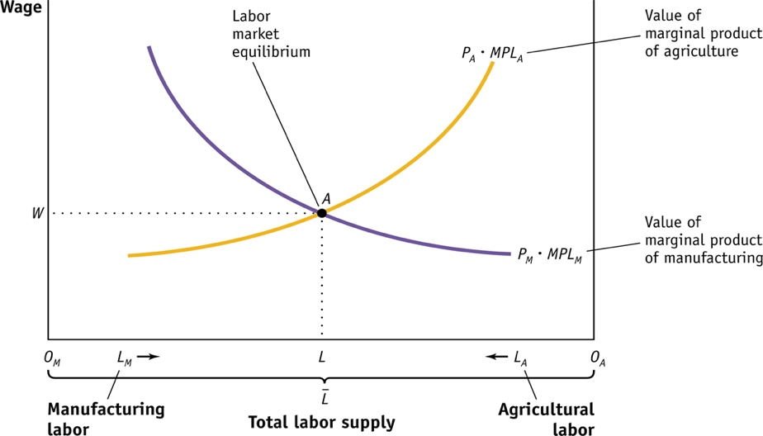

* The horizontal axis denotes the total amount of labor, $\overline{L}$, with the amount of labor used in manufacturing, LM, measured from left (0M) to right, and the amount of labor used in agriculture, LA, measured from right (0A) to left.
* The equilibrium wage is given by the intersection of the marginal product of labor in each sector multiplied by its respective price.
* With the equilibrium wage at point A, the economy uses 0ML units of labor in manufacturing and 0AL units of labor in agriculture.

**Effect of Change in Relative Price of Manufactures on the Wage**

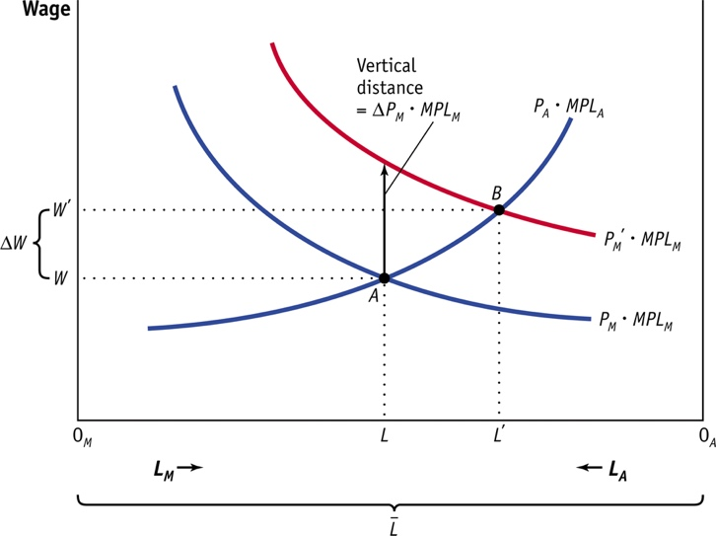

Suppose the higher relative price of manufactures is due to an increase in the price of manufacturing, PM.

* This shifts PM * MPLM to the right
* The new equilibrium nominal wage is higher than the old equilibrium nominal wage

**Effect on Real Wages**

Real wage in terms of manufactured goods W / PM falls

Real wage in terms of agricultural goods W / PA increases

* Whether labor is better off or worse off due to the increase in the price of manufactures depends on whether the individual prefers to purchase more manufacturing goods or agricultural goods.
* An increase in the price of manufactured goods results in an ambiguous effect on the well-being of labors since the effect on real wage is undefined.